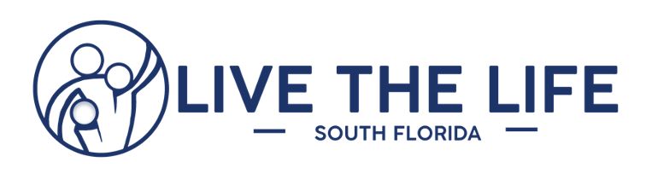

Comprehensive Cumulative Evaluation Results: 8 Questions in Total
Class Dates: May 2016 through June 2022
2170 people were asked the following question:
1. Considering all things, how happy would you say your relationship with your spouse/partner was just BEFORE the program? (GROUP AVERAGE indicated by blue)
Or AFTER the program? (GROUP AVERAGE indicated by green)
What’s the Academic Grade on the Relationship?
(Before & After our Marriage Programs)
Beginning Ending
22% Rated their marriage an “A” or higher (9-10) 70%
40% Rated their marriage a “B” or higher (8-10) 87%
60% Rated their marriage a “C” or less (1-7) 13%
33% Rated their marriage a “D” or less (1-6) 7%
22% Rated their marriage an “F” (1-5) 5%

Over 1,600 people were asked the following 4 questions:
2. My spouse/partner and I have the knowledge and skills to communicate well

3. I am confident in our ability to resolve conflicts in a healthy way

4. I am good at seeing problems/issues from my spouse’s/partner’s point of view
5. In our relationship it is “safe” emotionally for me to confide and share with my spouse/partner

More than 2,300 people were asked the following questions:
6. Would you recommend our marriage program? (2304 said YES, 10 said NO)

7. Gender Surveyed? (1109 MALE and 1185 FEMALE)
712 people were asked the following question:
8. On a scale of 1-10 (1 being lowest, 10 being highest), what is the overall rating you would give for the marriage program?
Out of 712 people, the average rating for Live the Life South Florida marriage programs were given a 9.26 out of 10.0

________________________________________
- Metrics for this Report include the following Programs:
-Hope Weekend (Christian Based Marriage Intensive)
-Adventures in Marriage (Christian Based Marriage Program)
-Reclaim (Secular Version of Marriage Program)
-Power of US (Christian Based Marriage Program)

